JCE SOCIAL STUDIES
FORM 1- 2

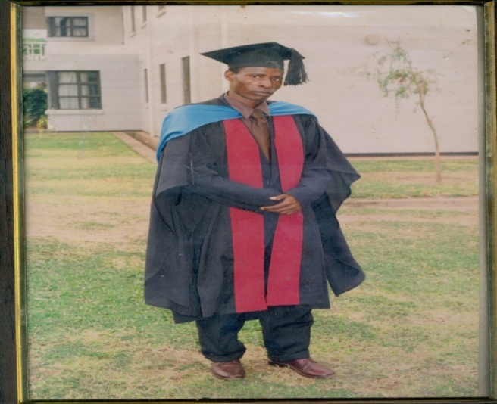

COMPILED BY
HARRY MATIMBA CHIDAONDA (0888676718)
(GRADUATE OF THE UNIVERSITY OF MALAWI)

